**Section 1:  
Questions 1 and 2**  
Complete the notes below. Write **NO MORE THAN THREE WORDS OR A NUMBER.**

#### **Conversation between a Student and a Job Advisor**

Type of job required: Part-time  
Student is studying **(1) __________**  
Student is in the **(2)** **__________**  year of the course.

**Questions 3-5**  
Complete the table below. Write **NO MORE THAN TWO WORDS.**

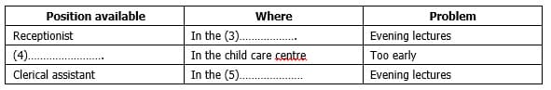

**Questions 6-10**  
**Complete the form below.**  
Write **NO MORE THAN THREE WORDS OR A NUMBER.**

**Section 2:  
Questions 11-16**  
**Choose the correct letter A, B or C.**

#### **SPONSORED WALKING HOLIDAY**

**11. On the holiday, you will be walking for**

**A** 6 days  
**B** 8 days  
**C** 10 days

**12. What proportion of the sponsorship money goes to charity?**

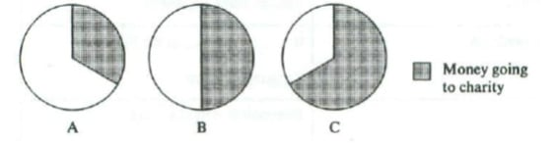

**13. Each walker’s sponsorship money goes to one**

**A** student  
**B** teacher  
**C** school

**14. When you start the trek you must be**

**A** interested in getting fit  
**B** already quite fit  
**C** already very fit

**15. As you walk you will carry**

**A** all of your belongings  
**B** some of your belongings  
**C** none of your belongings

**16. The Semira Region has a long tradition of**

**A** making carpets  
**B** weaving blankets  
**C** carving wood

**Questions 17-20**  
Complete the form below.  
Write **ONE WORD ONLY.**

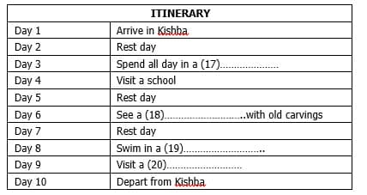

**Section 3:  
Questions 21 and 22**  
Complete the notes below. Write **NO MORE THAN TWO WORDS OR A NUMBER.**

### **OCEAN RESEARCH**

**The Robotic Float Project**  
• Float is shaped like a **(21)**___________  
• Scientists from **(22) ___________**  have worked on the projects so far

**Questions 23-25**  
Complete the diagram below.  
Write **ONE WORD OR A NUMBER.**

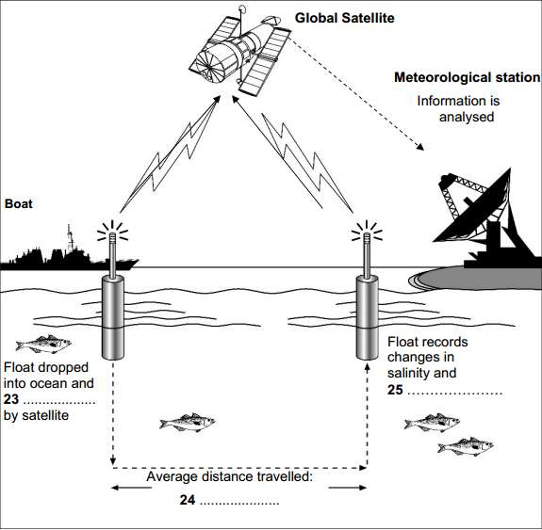

**Questions 26-30**  
**In what time period can data from the float projects help with the following things?**Write the correct letter A, B or C next to questions 26-30.

**26**. understanding of El Nino  
**27**. understanding of climate change  
**28**. naval rescues  
**29**. sustainable fishing practices  
**30**. crop selection

**A** At present  
**B** In the near future  
**C** In the long term future

**Section 4:  
Questions 31-34**  
Choose the correct letter A, B or C.

### **Hotels and Tourist Industry**

**31. According to the speaker, how might a guest feel when staying in a luxury hotel?**

**A** impressed with the facilities  
**B** depressed by the experience  
**C** concerned at the high costs

**32. According to recent research, luxury hotels overlook the need to**

**A** provide for the demands of important guests  
**B** create a comfortable environment  
**C** offer an individual and personal welcome

**33. The company focused their research on**

**A** a wide variety of hotels  
**B** large, luxury hotel chains  
**C** exotic holiday hotels

**34. What is the impact of the outside environment on a hotel guest?**

**A** It has a considerable effect  
**B** It has a very limited effect  
**C** It has no effect whatsoever

**Questions 35-40**  
Complete the notes below. Write **ONE WORD ONLY.**

**A company providing luxury serviced apartments aims to:**  
• cater specifically for **(35) ___________**  travellers  
• provide a stylish **(36)** ___________ for guests to use  
• set a trend throughout the **(37)** ___________ which becomes permanent

**Traditional holiday hotels attract people by:**  
• offering the chance to **(38)** ___________ their ordinary routine life  
• making sure that they are cared for in all respects – like a **(39) ___________**  
• leaving small treats in their rooms – e.g. cosmetics or **(40) ___________**